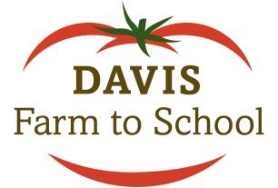
School Garden Grant Application Application deadline: November 1, 2021

Overview: Davis Farm to School is offering a grant opportunity for Davis school gardens. Grants provide up to $500 per school. Matching funds are encouraged but not required. Matching contributions typically come from a school site’s PTA/O, but may also come from other sources such as individual contributions, booster clubs, or local businesses.

Funds are for direct support of Davis school garden programs and uses for the grant may include:
- Purchase of seeds, plants, supplies, or equipment;
- Stipends for Garden Coordinators;
- Professional development opportunities;
- Garden curriculum; or
- Supplies and materials for projects that enhance connections between the school garden and the classroom, cafeteria, or waste reduction program.

Requirements to apply:

- Complete application, including all signatures.
- Return application by Monday, November 1, 2021 to Davis Farm to School to info@davisfarmtoschool.org

Grant recipients will be announced on November 15, 2021. Funds will be sent via USPS to the recipient of funds at school address provided, unless otherwise arranged.

Requirements if proposal is selected for funding:

- Submit End of Year Report to Davis Farm to School by June 30, 2022 (submission of Grant Report is required to be eligible for future funding).
- Garden coordinators must attend two Davis Farm to School Team Meetings during the 2021-2022 school year (dates to be determined) or send a representative on their behalf. Meetings are open to the community and others are encouraged to attend (more information will be provided in advance of each meeting).

The mission of Davis Farm to School is to create an educational and cultural environment in our schools that connects food choices with personal health, community, farms and the land.
Davis Farm to School supports all Davis schools in their goals to provide farm and garden-based education, increase farm fresh foods in school meals, and reduce solid waste through recycling and composting programs.
Davis Farm to School is a project of the non-profit Davis Farmers Market Alliance.

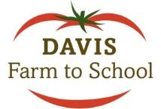
School Garden Grant Application
2021 – 2022 School Year (Page 1)

Contact Information:

School Site Name _____________________________________________

Address ______________________________________________

School Garden Garden Coordinator Name _______________________________

Email ________________________________________________

Phone _______________________________________________

Funds If awarded grant, check should be made payable to:
_____________________________________________________

Matching Funds? (circle one) Yes No

Signatures
X_________________________________________

Date: _____
Representative for School Garden

X__________________________________________

Date: _____
Representative for Matching Fund Donor (optional)

X__________________________________________

Date: _____
Principal

School Garden Grant Application
2021 – 2022 School Year (Page 2)

Project Proposal

- Describe your existing school garden. How is it used by classroom teachers and/or students? Include approximate number of teachers, students and volunteers involved. If not currently active, explain circumstances and future plans.

- Describe three goals for the school garden this year. Be specific. If possible, include teachers, approximate number of students and grades to be involved, connections to classroom curriculum, and how plans will further garden-based learning at your site.

- Describe your planned use for grant funds.

